
FARNINGHAM WI
August 2026
Following weeks of glorious sunshine, it seems apt that this evening`s speaker, Brian Nobbs, should be focussing on gardening. We can look forward to finding out how we can make ours more wildlife friendly.
EXPLORE RYE !
Check out the independent shops, find a vintage bargain and enjoy a fish and chip lunch (payable on day)
24th September
Sign the board this evening if you`ll be joining us.
Coach departs FVH at 9.30 a.m.
Due to the increased costs of coach hire we are asking ladies to contribute £10 each . The remainder will be covered from the Ted Saxton legacy.
Payments to Lesley or via BACS

Our next POP IN for £1 is on AUGUST 21st 2.00-4.00
Join us for tea and cake, good company , a fun quiz and lots of smiles
Bring along a couple of photos that include you that you really like – we`ll indulge in some feel-good memories !

HAPPY BIRTHDAY TO
Anne (9th), Bridget (12th) Micaela (15th) Tina (18th) Jane (18th) and Nicola (27
A MESSAGE FROM NFWI
It was with great sadness that we learned of the very sudden death of Kathleen Newins.
She was a positive, enthusiastic and popular member.
Our condolences have been sent to her family.
All members are invited to
submit proposals for our
2027 campaign.
Interested?
See Marilyn for
further details
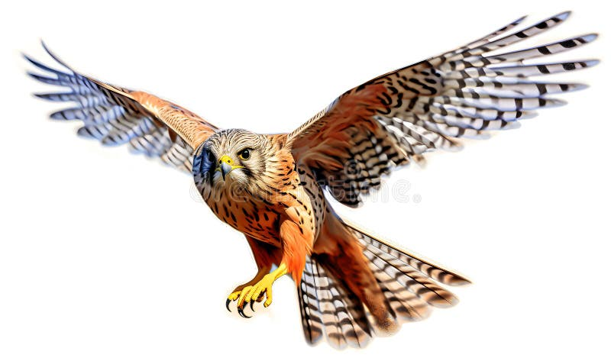
AFTERNOON TEA AT EAGLE HEIGHTS
SEPTEMBER 10th 10.30 -3.00
Explore Eagle heights and enjoy a flying display before sitting down to indulge yourself with a full afternoon tea.
£20 pp
Please sign the board at this evening`s meeting and/or contact Micaela
Payments to Lesley or via BACS
NEWS FROM OUR GROUPS
PA & I LUNCH 12/8/26 12 for 12.30 FVH (Marianne)
BOOK GROUP 7/9/26 7.00 Join the Whats App group (Tina)
SCRABBLE 14/8/26 2.00-4.00 FVH Join Lynda`s `Whats App` Group
CRAFT `Quilt-a-noon` 23/10/26 2.00-4.00 More details to follow

WEST KENT FED
- FEDERATION DAY TWO 23/9/26 Ditton Community Centre ME20 6AH 10:30am to 3:30 pm, doors open 9:30am £15 (?)
3 interesting speakers
- SPEAKER AUDITIONS 12/9/26 St John’s Church Hall Hildenborough, Tonbridge TN11 9HT 9.30 for 10.00 s £10
See info and WK News on stage . All bookings via Sharon
THANK YOUs from Kay N and Brenda J for the flowers they received after their recent stays in hospital. Thankfully , they are now both home and on the mend.

SEPTEMBER MEETING !
- We`ll be celebrating WI day (Sept 16th) . Be a part of it by wearing something purple
Why? Purple was the colour of Suffragettes and symbolises loyalty, creativity and wisdom – values that are very WI!
ENTER OUR COMPETION
“My Garden in August”
Bring a photo, a posy, home-grown veg or……
STEWARDS
KITCHEN : Sally Armstrong, Helen Barwick + 1
ROOM : Tina Renshaw, Bridget Lockwood
- REMEMBER ! IF YOU ARE UNABLE TO COVER YOUR ROOM OR TEA DUTY, YOU SHOULD FIND A SWOP

OUR WEBSITE ADDRESS IS : Farninghamwi.co.uk Or just `google` Farningham WI and a link should magically appear!

PAYMENTS BY BACS :
FARNINGHAM WOMENS INSTITUTE
Sort code : 20-25-42
Acc No : 30367095

095

NB If you incur any expense e.g. making cakes, supplying goods, for the WI , see Lesley, with proof of purchase, to claim back your expenses. Nobody should be out of pocket because they`ve been helpful !
PAYING IN CASH ?
If you are making cash payments to Lesley, she would be grateful if you could put the correct money in a sealed envelope with your name, the amount and what the payment is for and pop it in the box on the President`s table.

