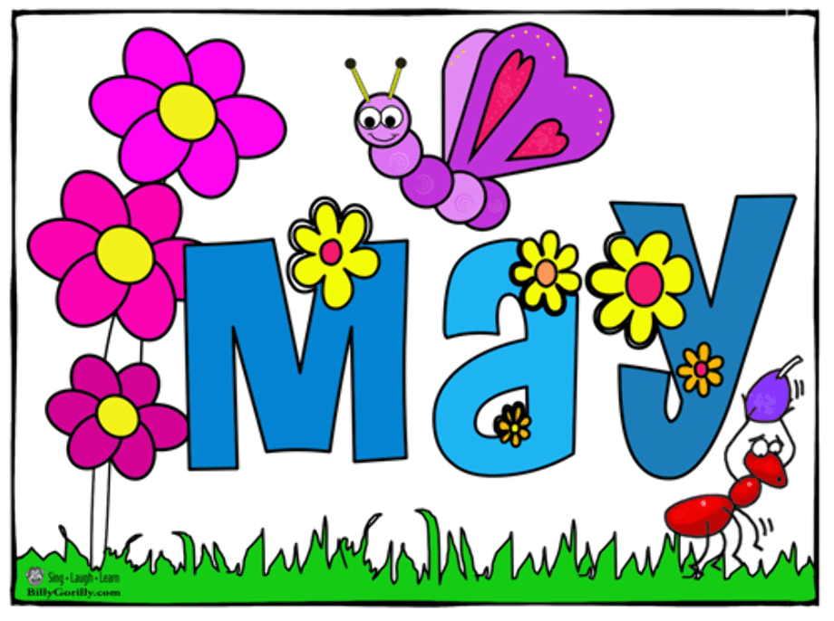
FARNINGHAM WI
WELCOME TO OUR ANNUAL AGM!
We`ll be reviewing our year and electing this year`s committee and President…….and there`s a place on the committee that is just perfect for YOU!
No particular talent or skill needed : just common sense, positivity, a willingness to help and a sense of humour.
We promise that you won`t be asked to do anything that you don`t feel confident or comfortable about! And it`s fun!
"Ask not what your WI can do for you— ask what you can do for your WI"

TIME TO CELEBRATE! At our June Meeting we`ll be celebrating our 108th Birthday!
THURSDAY JUNE 4th
Join us from 7 .00 for drinks, buffet meal and entertainment from
The Ukelele Group.
Please sign the board tonight if you can join us.



Our next POP IN for £1 is on FRIDAY MAY 15th 2.00-4.00
Join us for tea and cake, good company, lots of smiles and a few surprises.
Please sign the board tonight if you`ll be joining us


CAKES! CAKES! CAKES!
Calling all bakers!
We`ll be running the Refreshment Tent at the Church Fete on
SATURDAY JUNE 13th
Cakes urgently needed – please sign the board if you can help .
Deliver your cake to our tent on the day from 10.30 or leave at Marilyn`s house on Friday 12th.

Following the Supreme Court Judgement re gender all members are required to complete a new membership form.
Have you done yours yet? If not, please see Brenda

West Kent Fed
20th June 10.00 ART & CRAFT DABBLE DAY Hildenborough £15
7th July 9,30 FEDERATION DAY NORTH Bat & Ball £20
See info and WK News on stage . All bookings via Sharon
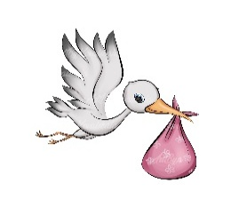

NEWS FROM OUR GROUPS
PA & I LUNCH 13/5/26
12 for 12.30 FVH (Marianne)
BOOK GROUP 18/5 /26 7.00
Join the Whats App group (Tina)
SCRABBLE 22/5/26 2.00-4.00 FVH
Join Lynda`s `Whats App` Group
CRAFT Watch this space for the date for a Quilt – a- long!

Happy Birthday !
Marion Corver (1 st )
Linda Lees (2 nd )
Sheila Oakes (2 nd )
Kay Cordingley (4 th )
Viv Parker (8 th )
Jan Michener (9 th )
Caroline Noble (19 th ) Sally Armstrong (14 th )
Lorraine Newby (22nd) RosemaryLeakey (23 rd) Bernie Jeffery (27 th )
On June 6th DAWN JONES who joined us in January , will trek Mount Snowdon to support The Eve Appeal .
This is the leading gynaecological cancer charity, aiming to prevent the development of womb, ovarian, cervical, vulval, and vaginal cancers and support early detection. Any donation, regardless of size, helps support this important work and can save lives across the UK.
Donation Link: https://www.justgiving.com/page/adam-dave-dawn-faye-4?utm_medium=FR&utm_source=CL
Charity Information: https://eveappeal.org.uk/
See Dawn for more information
PLEASE NOTE : this is an independent initiative and is not connected to Farningham WI .

THANK YOU to everyone who has paid this year`s subs .
These are now due and any outstanding payments should be made to Lesley (or Brenda this evening) - cash in a named envelope, cheque (payable to Farningham WI ) or BACS (info below)
SAVE THE DATES!
You may remember that, due to increased numbers, we are changing the format of our Christmas celebrations.
As well as a festive-themed main meeting , following consultation, we shall be organising a traditional Christmas Lunch on Sunday November 29th (2.00-4,00) at Darenth Valley Golf Club in Shoreham
Also in the pipeline, a Christmas Crafternoon on December 11th to make table decorations .

REMEMBER ! IF YOU ARE UNABLE TO COVER YOUR ROOM OR TEA DUTY, YOU SHOULD FIND A SWOP

OUR WEBSITE ADDRESS IS : Farninghamwi.co.uk
Or just `google` Farningham WI and a link should magically appear!

PAYMENTS BY BACS :
FARNINGHAM WOMENS INSTITUTE
Sort code : 20-25-42
Acc No : 30367095

095

PAYING IN CASH ?
If you are making cash payments to Lesley, she would be grateful if you could put the correct money in a sealed envelope with your name, the amount and what the payment is for and pop it in the box on the President`s table.

NB If you incur any expense e.g. making cakes, supplying goods, for the WI , see Lesley, with proof of purchase, to claim back your expenses. Nobody should be out of pocket because they`ve been helpful !

