
FARNINGHAM WI
APRIL 2026

It`s that time of year again and Lesley is looking forward to collecting your 2026 subscription payments!
The cost is £54 per person , which may sound a lot initially, but not when you consider that it covers 12 main meetings, group meetings hall hire , speakers , subsidised events and lots of `extras` and treats
It`s worth remembering that each £54 is split 3 ways :

We receive £27.10 ;
WK Federation receives £12.55
NFWI receives £14.35
You can pay by cheque or cash (correct money in a sealed envelope please) or BACS . Further information at the end of this newsletter .

Following the Supreme Court Judgement re gender being defined as that assigned at birth , the WI has amended the membership form. All members are required to complete the new one.
Brenda will be explaining more this evening and distributing and collecting copies.
(The revised ED& I policy applies from 1st April. More info on the stage)
WK ANNUAL GENERAL MEETING
Marilyn and Linda spent an enjoyable day at last month`s Federation AGM in Gravesend and Marilyn will be reading a short report this evening.
As agreed, we took a bag of donations for the Gravesend Food Bank, financed from last month`s raffle.

Spring stroll : Hall Place and Gardens , Bexley
Monday 13th April
Meet at 10 o clock by entry gate to gardens
It`s not too late to join us for our short visit later this month.
There`s plenty to do : marvel at the butterflies close up in the indoor Butterfly Garden (small fee payable); wander the tranquil grounds ; enjoy a chat and a snack in the Riverside Café ; check out the latest exhibition in the Stables Art Gallery.
Interested ? Sign the board or see Marj
Hall Place is situated on the edge of Bexley Village, just off the A2, around a 20 minute drive from Farningham. Ample free parking.
POP in for £1 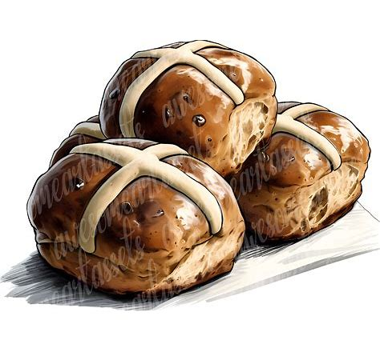
Our Easter Pop In was a very tasty affair! Ladies tucked into samples of buns and declared that the best was Tesco `Extra Fruity` , way ahead of the second Asda `Extra Fruity`. Close behind, in 3rd place was Tesco `Richly Fruited`. (Sainsbury`s inhouse bakery buns got a real thumbs down!)
Ladies also enjoyed Easter buns, solved cryptic clues to identify popular chocolate bars ( a close- run competition with 2 tie breaks!) and tried their luck at an Easter gift bag raffle. It was a busy afternoon
Thank you to Micaela and Lesley who organised the taste test, Lynda , Ann , Rita and other helpers who served teas and Marilyn who baked the buns.
Our next POP in is on FRIDAY April 17th 2-4
Please sign the board this evening
Future dates so far : May 15th , June 19th

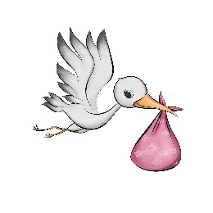 Happy Birthday to Jill (2nd) Kay G (3rd)
June (8th) Sally F (12th) Sally O`C (15th) Marianne C (16th),
Kathleen (16th) Iris (21st) Laura (27th) Sharon M (29th)
FRIDAY MAY 8th 2.00-4.30
Annual General Meeting and Cream Tea
Join us for a review of the past year and to elect our
2026-27 committee !
(Please sign the board to inform catering)

Now is the time to think about joining the committee !
No particular talent or skill needed :
just common sense, positivity , a willingness to help and a sense of humour.
We promise that you won`t be asked to do anything that you don`t feel confident about! And it`s fun!

“YOUR WI NEEDS YOU! “
"Ask not what your WI can do for you— ask what you can do for your WI"
“Every little helps!”
(With apologies to Lord Kitchener, JFK and Tesco)

NFWI Raffle tickets are now on sale! £1 each
This year`s prizes include £10, 000, a cruise on the Danube and top price West End theatre tickets.
See Lesley for more info

Geoffrey Whitworth theatre
30th June 7.30.p.m. £15 pp
Please sign the board or see Marj before the end of April

Message from Friends of Farningham 2026
We are dusting off our gardening gloves .ahead of the forts meeting on Saturday 4th April
Meet at 10.00 at the village hall . New volunteers very welcome
2026 dates : 2nd May, 6th June, 4th July , 1st August , 5th September

West Kent Fed: 3 events worth checking out!
- 1ST MAY 7.15 MURDER MYSTERY @ St Mary`s Platt £15

- 15th May 10.30 AUTHORS` DAY Bat and Ball £15

- 20th June 10.00 ART & CRAFT DABBLE DAY Hildenborough £1
See the WK News on stage or on our website or ask Sharon for more information. All bookings via Sharon

NEWS FROM OUR GROUPS
PA & I LUNCH 8/4/26 12 for 12.30 FVH (Marianne)
BOOK GROUP 20/4/26 7.00 Join the Whats App group (Tina)
SCRABBLE 10/4/26 2.00-4.00 FVH Join Lynda`s `Whats App` Group
DRAMA TBC
Join the `Whats App` Group or see Brenda J

MAY STEWARDS
Teas : Pat S and Julie
Room : Laura and Jill
REMEMBER ! IF YOU ARE UNABLE TO COVER YOUR ROOM OR TEA DUTY, YOU SHOULD FIND A SWOP

OUR WEBSITE ADDRESS IS : Farninghamwi.co.uk
Or just `google` Farningham WI and a link should magically appear!

PAYMENTS BY BACS :
FARNINGHAM WOMENS INSTITUTE
Sort code : 20-25-42
Acc No : 30367095

095

PAYING IN CASH ?
If you are making cash payments to Lesley, she would be grateful if you could put the correct money in a sealed envelope with your name, the amount and what the payment is for and pop it in the box on the President`s table.

NB If you incur any expense e.g. making cakes, supplying goods, for the WI , see Lesley, with proof of purchase, to claim back your expenses. Nobody should be out of pocket because they`ve been helpful !

