
Farningham WI
January 2026

It was great to see so many smiles at our Christmas Meeting and Pop-In .We hope that you all had a lovely Christmas and wish you a happy and healthy 2026 !
(Be sure to check out Marj`s photos at today`s meeting! )
REMEMBER……to cast your vote today!
Make your choice from the shortlisted Resolutions below. Our decisions will be forwarded to NFWI and included in returns from all over the UK
The most popular will be debated at the Annual Meeting in June and if agreed, i will form the basis of next year`s campaign.

Accessible public toilet facilities to promote dignity, health, and social inclusion - a call for accessible, clean, free public toilets especially for women, older people, disabled individuals, parents and carers

Action on women’s homelessness - action to reduce women’s homelessness, reduce the number of women at risk of homelessness, and improve the quality of temporary accommodation.

Every child needs a friend - a call to WI members, the care system, and government to raise awareness of the independent visitor system for children in care in order to increase the number of volunteer Independent Visitors

Love Your Vulva : self checking is your best defence against vulval cancer - self-checking your vulva is important in ensuring the earlier detection of vulval cancer and to enhance survival chances
.
Nearer to Nature - a call to WI members to work locally to improve access to local green spaces and support others to access it too.

You can now enjoy your tea in a cup or mug !
Thank you to Lynda for her donation of 40 mugs.
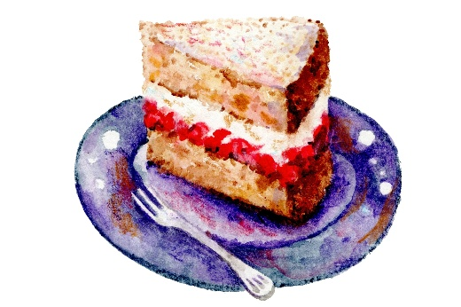

Pop In for a £1 !
Friday January 23rd 2.00- 4.00
Beat those Winter Blues!
Join us for good company, lots of laughs and a few surprises!
Sign up tonight !

It`s Panto time! (Oh no, it isn`t!)
Riverside Players
“Beauty and the Beast”
January 23rd at 7.45 EVH
Anne is organising tickets for a WI group
Fancy joining us? Info and board on the stage

Message from NFWI
Following last year`s court ruling, from April 2026, we can no longer offer formal membership to transgender women. However, we will be launching a national network of local WI Sisterhood groups, offering monthly opportunities for all people, including transgender women, to come together to socialise, learn from each other, and share experiences of living as women.
Further information and guidance will be issued plus details of other ideas that are being explored.
WK AGM
NEWS FROM OUR GROUPS
PA & I LUNCH 14/1/26 12 for 12.30 FVH (Marianne)
BOOK GROUP 19/1/26 7.00 Join the Whats App group (Tina)
SCRABBLE . 16/1/26 2.00-4.00 FVH Join Lynda`s `Whats App` Group
DRAMA TBC
Join the `Whats App` Group or see Brenda J

Wed March 18th 2026
Woodville Halls, Gravesend
Marilyn will be our delegate but
you can attend as a non-voting
member. Tickets £13.50.
You can also enter the draw for a
Bursary and/or enter the poetry
or Art & Craft competition.
Check out the info on the stage and/or
see Marilyn
HAPPY BIRTHDAY
Judy Mc(3rd), Pat G (6th), Sylvia Cl (8th) Denise (11th), Lynda (11th)
Julia (19th), Lorraine M (29th), Vikki (30th) Jackie (31st)

FEBRUARY STEWARDS
TEAS : Viv and Sandra
ROOM : Sally S and Caroline N
REMEMBER ! IF YOU ARE UNABLE TO COVER YOUR ROOM OR TEA DUTY, YOU SHOULD FIND A SWOP

OUR WEBSITE ADDRESS IS : Farninghamwi.co.uk
Or just `google` Farningham WI and a link should magically appear!

PAYMENTS BY BACS :
FARNINGHAM WOMENS INSTITUTE
Sort code : 20-25-42
Acc No : 30367095

095

NB If you incur any expense e.g. making cakes, supplying goods, for the WI , see Lesley, with proof of purchase, to claim back your expenses. Nobody should be out of pocket because they`ve been helpful !

