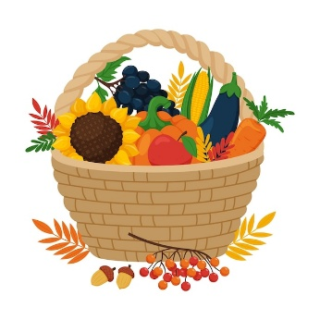
FARNINGHAM WI
September 2025

Looking forward to seeing you at our
AUTUMN LUNCH at THE HILLTOP
Saturday September 13th 12.30 for 1.00
REMEMBER Although welcome drinks and lunch are included , further orders are at your own expense
We are grateful to our benefactor whose donation enables us to offer this to our members as a free event. Her generosity is much appreciated.

Have you signed up yet? Action now, could save a life….
BRUSH UP YOUR CPR !
Friday September 19th 10.00-12.00
A relaxed, informal session with a local paramedic.
Tea/coffee and cookies £4 pp
Please sign the board if you can make it.


Please bake a cake for our
RESTART-A-HEART COFFEE MORNING
SATURDAY OCTOBER 11th 11-1.00
Proceeds to British Heart Foundation and St John`s Ambulance
Board on the stage

“FARNINGHAM WI REVEALED ….AND REVISITED”
October 17th 2-4
Join us for a great afternoon !
- Enjoy a Fish and Chip Lunch
- Explore the picture display of our `dramatic past`
- Sit back and enjoy the premiere of “The Committee” – the first production from our newly-formed Drama Group
- Test your powers of deduction in our `surprise item`

£ 10 pp payable September and October meetings or via BACS
Please sign the board to inform numbers and catering
CRAFTY BUSINESS !
Friday October 3rd 2.00-4.00
An uplifting heart-themed creative session supporting our “Bystanders can be Lifesavers” campaign!
Four EASY crafts : heart-shaped felt brooches , beaded heart bookmarks, lavender-filled heart sachets and beautiful heart-memory wire bracelets!
No experience necessary .
All materials supplied, plus plenty of tea, coffee and homemade cake to keep us crafting. All included in the £4pp cake – a snip !
We hope to sell our heartfelt creations at our upcoming Coffee Morning in aid of the British Heart Foundation,
Gather your friends for a great afternoon and show a little heart for this life-saving cause!
Please sign the Crafternoon board on the stage

NFWI UPDATES
Emma Bridgewater has extended her range of specially-designed WI pottery, Interested? Check out her website www.emmabridgewater,co,uk
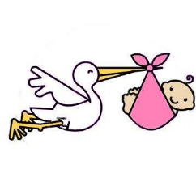HAPPY BIRTHDAY
NEWS FROM OUR GROUPS
PA & I LUNCH 10/9 /25 12 for 12.30 FVH (Marianne)
CRAFT 3/10/25 2- 4 Crafternoon
(Micaela) See above
BOOK GROUP Oct TBC Join the Whats App group (Tina)
SCRABBLE . 12/9 2.00-4.00 FVH Join Lynda`s `Whats App` Group
DRAMA 5/9/25 2-4 Main hall
Join the `Whats App` Group or see Brenda J

to our SEPTEMBER babies babies
Peggy (5th)
Margaret (8th)
Brenda J (11th)
Sylvia Cr (13th)
Christine (16th)
Tonya (22nd)
Sharon B (26th)
THANK YOU
SALLY A AND SHEILA P FOR DONATIONS OF CUTLERY

WK NEWS

- 16/10 (Hextable) 18/10 (Orpington) Matthew Palmer Watercolour workshops £36 to cover cost of all supplies
- 22/10 Lifestyle Annual Day Ditton £15 . 3 excellent speakers
- Enter the Kay Moore Cup with an original Art / Craft entry to be displayed and judged at the AGM in March 2026
- Further details of the above and other events can be found in the copy of WK News on the stage or our website.
- All applications via Sharon B

SAVE THE DATES !
FRIDAY OCT 24th Social Afternoon and fun auction
Start sorting out your pre-loved items now! More information next month .
All proceeds to Farningham WI No clothing please!

Back by popular demand …….OUR NEXT POP-IN !
Friday November 7th 2-4 . Info and board next month.

REMINDER Bring your empty tablet strip/ containers , used cartridges and batteries and Marj will arrange recycling
OCTOBER STEWARDS
TEAS Rosemary Leakey, Lee Mullins ROOM :Karen Henry, Jane Towers
PLEASE REMEMBER ! IF YOU ARE UNABLE TO COVER YOUR ROOM OR TEA DUTY, YOU SHOULD FIND A SWOP

OUR WEBSITE ADDRESS IS : Farninghamwi.co.uk
Or just `google` Farningham WI and a link should magically appear!

PAYMENTS BY BACS :
FARNINGHAM WOMENS INSTITUTE
Sort code : 20-25-42
Acc No : 30367095

NB If you incur any expense e.g. making cakes, supplying goods, for the WI , see Lesley, with proof of purchase, to claim back your expenses. Nobody should be out of pocket because they`ve been helpful !

