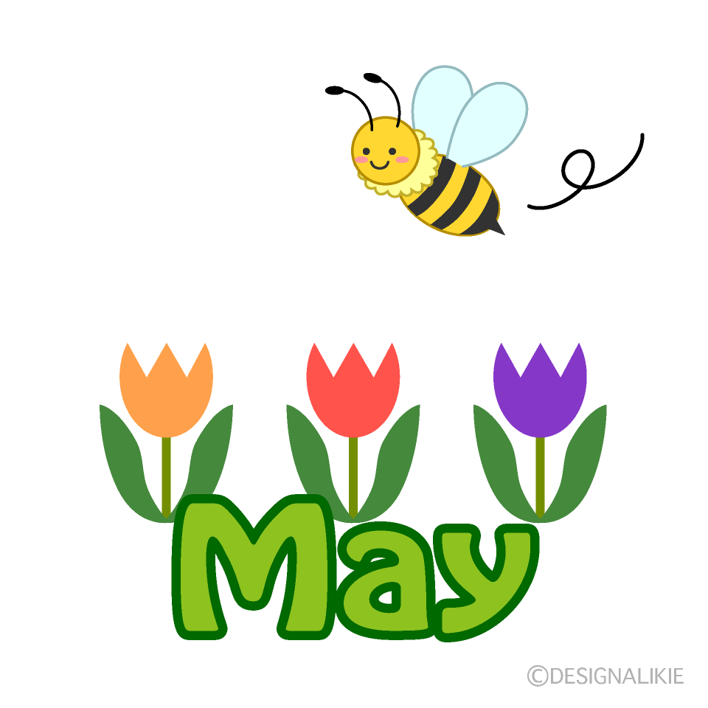FARNINGHAM WI
107 years and still going strong!
We`ll be paying homage to National Rose Month at our
birthday party on Thursday June 5th
The theme is “An English Rose” Will you wear a rose? On your outfit? In your hair ? Between your teeth?
Welcome drinks from 7 o clock followed by a buffet meal and entertainment from the singers of the East Kent Chorus.
Please sign the board tonight to inform catering.

It`s time for a big `shout-out`, a round of applause and pats on the back to……..
All those committee members who have consistently (and cheerfully) organised our activities over the last year
Jane, June and Laura who will be standing down from the committee tonight
Those ladies who have decided to sit on the new committee – and those who might still be persuaded !
Our unsung heroines : Joan (register), Denise (posies) , Sally and Linda (village hall reps )
The ladies who have already paid their subs (and those who soon will)
Our groups organisers – Marianne, Lynda, Micaela and Tina
…and all the room stewards, tea-makers, washers-up, cake-bakers, competition supporters, raffle-ticket-buyers (and donors) and `smilers`!
You all contribute to the success of our Wi - long may it continue!


AND A SPECIAL MENTION FOR
Tonya, who has decided to hand over the management of our website after over 10 years. She established it – one of the first in West Kent- and has diligently uploaded photographs, newsletter and meetings information on a regular basis. Thank you!
Thanks also to Micaela who will be following in her footsteps!

WEDNESDAY JULY 23rd
Visit to Hythe with Afternoon tea
Board the coach at 9.30 at the village hall
Visit the independent cafes and shops in the High Street
Stroll along the seafront
Enjoy afternoon tea at The Hythe Imperial hotel
£23.95 pp
Sign the board on the stage . Coach costs met from Ted Saxton legacy


Calling all bakers …..
We`ll be running the tea and cakes tent at the
CHURCH FETE on SATURDAY JUNE 14th
All offers of cakes very gratefully accepted
Please sign the board if you can support .
HAPPY BIRTHDAY !
Marion (1st), Sheila O (2nd) Linda L (2nd) Jan (9th) Caroline (13th) ,
Sally A (14th) Lorraine N (22nd) Rosemary (23rd) Bernie (27th)

CLOTH DOLL CRAFTERNOON
Friday, 23rd May | 2:00-4:00 PM FVH
Join us for a delightful afternoon of doll-making! Whether you're a seasoned sewer or just beginning, create your own charming cloth doll with our provided pattern. Hand or machine sewing options available.
Cost: £3 (includes hall hire, refreshments, and some materials)
We'll Provide: • Pattern, instructions and stuffing • Sewing machines (limited number) • Removable fabric pens • Wool for hair • Tea and refreshments
Please Bring: • Body fabric (50x50cm): Cotton or medium-weight non-stretch fabric • Dress fabric: Light-medium weight cotton • Lining fabric: Lightweight non-stretch • Sewing thread (polyester) • Black embroidery thread for face details • Basic sewing supplies (scissors, pins, needles) • Your own sewing machine (if possible)
Optional: Bring your personal touch with ribbons, buttons, or trims!
Sign up on the board to reserve your space
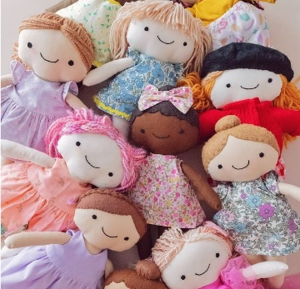
NFWI & WK EVENTS
“Introduction to Pastels “
21st June St Nicholas Church hall Orpington £29 Info on stage
Bookings via Jane

2025 NATIONAL CAMPAIGN
“Bystanders Can be lifesavers”
The resolution we discussed and voted upon last month will be taken forward to the Annual Meeting in June for adoption. If it`s agreed, we`ll be busy over the next year.
Look out for a CPR brush-up session (16th Sept ) , publicity at local events and yarn-bombing . We`ll also be holding sessions to make small heart-themed craft items for a fund-raising stall , on behalf of British Heart Foundation and St John`s Ambulance , at a special Coffee Morning on October 11th. Save the dates!

NEWS FROM OUR GROUPS
PA & I LUNCH 11/6/25 12.00 for 12.30 FVH (Marianne)
CRAFT “Come `n Craft” 2/6/25 2.00-4.00 FVH (first Friday of each month going forward) (Micaela )
BOOK GROUP 2/6/25 7.00 FVH Join the Whats App group (Tina)
SCRABBLE 16/5/25 2.00-4.00 FVH Join Lynda`s `Whats App` Group
FRIDAY WALKS – We`re starting the new season with an easy walk along Sparepenny Lane to Eynsford and back with coffee at the Shand Hall after.
30/5/25 Village hall for 9.30 start
PAYMENTS BY BACS :
FARNINGHAM WOMENS INSTITUTE
Sort code : 20-25-42
Acc No : 30367095

NB If you incur any expense e.g. making cakes, supplying goods, for the WI , see Lesley, with proof of purchase, to claim back your expenses. Nobody should be out of pocket because they`ve been helpful !

PLEASE REMEMBER ! IF YOU ARE UNABLE TO COVER YOUR ROOM OR TEA DUTY, YOU SHOULD FIND A SWOP

