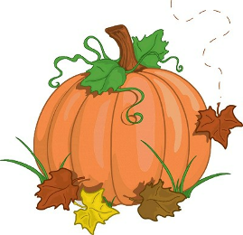Farningham WI October 2023

September was as VERY busy month and it was great to see so many ladies at our main meeting, PomPom Pop-In, walk to The Bull and Afternoon Tea, as well as group events.
October may well be a little quieter (to give us all time to recuperate) but preparations are already in hand for …………..

Christmas !
More information below …….but first ….

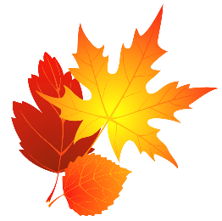 Stride into Autumn
with our Friday Walkers

Friday October 13th
Local walk followed by coffee at Shand Hall Village Hall 9.30
Friday Nov 17th
Otford circular walk followed by brunch at The Pond View Café
Meet in car park by Memorial Hall 10.00.a.m.

All dates and times tbc . Make sure that you are in the Whats App Group to receive updates.

BOWLS & BUNS! 
Join us on Friday November 10th 2.00 till 4.00
Try your hand at Short-Mat Bowls ! Enjoy a cup of tea , a homemade cake and a chat!


You can try it all or just one………
Small charge to cover cost of hall TBC

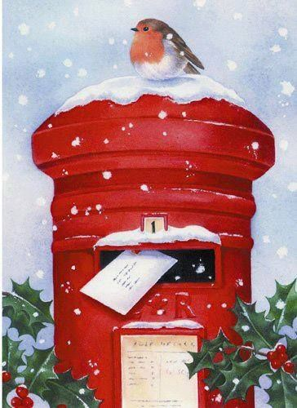It`s almost time for Marj to dust off the Christmas Postbox!

If you would like to send cards to anyone in Farningham WI, bring them along to the NOVEMBER meeting and we`ll distribute them for you on the December evening.

New ladies – please don`t think that you should send cards to everyone (we don`t!) , or even anyone at all . It`s completely your choice!

CHRISTMAS STARTS HERE!
Friday November 24th 2.00-4.00
Decorate Christmas Bags and Tags
Enjoy Festive Refreshments
Win a prize at the Christmas Tombola
...and pick up a free (very) mini-gift to take home! £6 pp
Bags , tags and glue sticks supplied but bring along some Christmas/coloured/shiny paper, ribbons etc and a pair of scissors

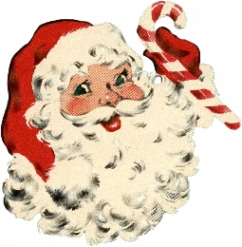Sign up…sign up….sign up …..
Join us for our Christmas Celebration at the December meeting .
Drinks and canapes from 7.00.p.m. followed by a 2 course meal and tea/coffee.
Expect a few surprises too!
Tick the list if you`d like to attend and enter your main course choice . Menu overleaf. Cost £15 pp payable to Brenda
(Many thanks to our benefactor for her generous donation which has enabled us to subsidise meal costs significantly )
Final date for orders and/or cancellations Nov 20th
CHRISTMAS MENU
Drinks on arrival
Selection of canapes
Main Course
Tarragon crusted sea bass served with new potatoes and green beans
Roast turkey, sage and onion stuffing, pigs in blanket, roast potatoes, buttered carrots with parsley, brussel sprouts, slow cooked red cabbage
Sweet potato, mushroom, walnut, and cranberry wellington (v) (ve) (n)
Dessert
Trio of tiny puds : orange posset, raspberry ripple cheesecake, chocolate truffles
Tea/Coffee

DONATIONS…DONATIONS……DONATIONS
…gratefully accepted for our themed
Christmas Hamper & Gift Box Raffle
at the Christmas Meeting .
Traditional foods, wrapping paper , tags, bags, toiletries, candles , Christmas sweets and chocs, Christmas bakes ……and any other festive goodies.
Bring them along to our October and November meetings or drop them off at Marilyn`s house
NFWI & WK NEWS
- The format of NFWI ACM is changing! From 2025, there will be a 3 year cycle : 2 meetings that will offer online participation only and 1 that will be a hybrid meeting at a venue allowing in person or online attendance.
- Invitation on stage from Otford Oast for Quiz and Fish & Chip Night 27th October, £20 p.p or £10 p.p without fish & chips.

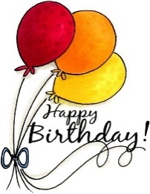
TO Brenda ( Oct 14th) and Sheila (Oct 13th)

NEWS FROM OUR GROUPS
FRIDAY WALKS Fri Oct 13th (see info above) Join Tina`s `Whats App` group to receive updates.
PA & I LUNCH WED Oct 11th 12.00 for 12.30 FVH ( Pam or Marianne) Board out tonight.
SHORT MAT BOWLS Fridays 1.30 Village hall (Irene)
BOOK GROUP 16th Oct 7.00 JA Room TBC `American Dirt` by Jeanine Cummins. Next Month :” Reasons to go outside” by Esme King
SCRABBLE 16th Oct 2.00 Lynda`s house Join her `What`s App` Group for updates
Best Wishes to Tina and Jill.
Tina is nursing a broken wrist after slipping on mud and Jill is recovering from a knee operation. We have sent flowers and cards from our WI

