
Farningham WI
March 2025
Thank you to everyone who supported our Winter Warmer Event last month and to Marj who put together the fun picture quiz. There were 2 scores of 45/50 but after a tie-break the triumphant winner was Jill. Congratulations plus a huge `Well Done` to our runners-up Sally, Kay, Micaela and Lesley.

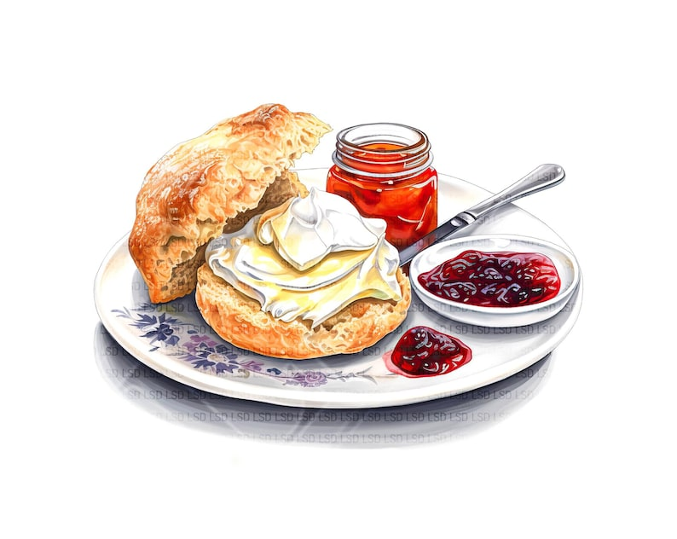ANNUAL GENERAL MEETIN G
Due to local elections the
DATE HAS BEEN CHANGED
We`ll now be meeting on
FRIDAY MAY 9th 1.30-4.00
Join us for a Cream Tea and a review of the year .
We`ll also be electing our Committee and President for 2025-26 .
Please sign the board if you are coming (to inform catering)
Offers to bake scones very gratefully received!
(See Marilyn)

Come and JOIN THE WI COMMITTEE !
What would I do?
Attend the monthly committee meeting to discuss future action and events

Support the running of the monthly meeting and events by taking on specific responsibilities …….

e.g. Micaela and Sharon write minutes of meetings and Brenda keeps membership records

…….and/or helping to organise specific events

e.g at the recent Winter Warmer event
Brenda booked the hall
Marj organised the quiz
Marilyn ordered the fish and chips
Lesley dealt with the money
Micaela, Lesley, Jane and Sharon set up the room
Sharon and Brenda made the tea – and washed up !
Lynda and Judy sorted out the raffle.

We promise that you won`t be pressurised into doing anything that you feel uncomfortable about!

You can do this! Have a chat with a member of the committee for more information and/or if you feel you can support in this way

Thank yous
To Linda F who has offered to join Sally as a WI representative on the Village Hall Committee…….
……and to Bernie who will be organising the competitions at our monthly meetings

FRIDAY MARCH 21st 2.00-4.00
Get to know your Groups!
Join us for sociable afternoon with tea and cake and a chance to hear all about our groups.
What goes on at PA& I, Book Group, Scrabble , Come `n Craft and Walking Group ?
Find out about the latest book or try your hand at a round of scrabble.
Group organisers will bring you up to date and would love to hear your suggestions and ideas
Donations of £1.50 payable on the day.
Please sign the list to inform catering.

ANNUAL PARISH MEETING March 28th
This will take place from 6.30.p.m. with Cheese and Wine and cakes (from us!) It is an opportunity to find out more about local community groups , raise community-related issues and meet local councillors.
Farningham WI will be represented and we`ll be sharing information about our activities. Why not pop in and see us ?

Our APRIL meeting
will have an Easter theme with an
“Easter Extravaganza” competition .
Easter craft, flowers, decorations and bakes all welcomed.
Go on, have a try………

Looking ahead ……we are in the process of checking out events for the rest of the year, including some pub lunches and a coach trip. Check out the boards on the stage to indicate possible interest and offer suggestions.
HAPPY BIRTHDAY to our march Babies !
Sally S ( 13th) Doreen ( 31st)

WK & NFWI NEWS

Thank you to everyone who took part in last month`s vote on the shortlist for the 2025 national Campaign . Our verdict was ……

Resolution  Number | Title of Resolution | Vote
1 | Let’s Talk about Incontinence | 13
2 | Bystanders can be Lifesavers | 7
3 | Join the Repair Revolution | 1
4 | Eliminate Landfill of Medication Packaging | 9

…which Jane has forwarded it to NFWI .
- West Kent Annual Meeting
Wednesday 19th March Woodville halls, Gravesend
Marilyn will be our delegate.
£20 from this evening`s raffle will be used to provide a bag of groceries for her to take to donate to Gravesend Foodbank.
- Thank you to Marianne who wrote a short obituary for Pam for inclusion in this month`s WK News. The link was circulated last week.
- Applications for tickets for WK courses and events should be made through your WI. Please see Jane if there are any in WK News that interest you

News from our groups
PA & I LUNCH 12/3/25 12.00 for 12.30 FVH (Marianne)
CRAFT “Come `n Craft” 7/3/25 2.00-4.00 FVH (first Friday of each month going forward) Micaela
BOOK GROUP 17/3/25 7.00 FVH Join the Whats App group
SCRABBLE 14/3/25 2.00-4.00 FVH Join Lynda`s `Whats App` Group
PLEASE REMEMBER ! IF YOU ARE UNABLE TO COVER YOUR ROOM OR TEA DUTY, YOU SHOULD FIND A SWOP

