 FARNINGHAM WI
March 2024

Easter Egg-stravaganza !
A pop-in with a difference ,
Friday March 15th 2.00-4.0
Would you like to :
Enjoy a cuppa and some scrumptious homemade cake
Take home a simnel cake
Win an eggsellent raffle prize
Make an Easy Easter Gift to take home
Find out “Who`s the Easter Bunny?”
Win a fluffy bunny
Match the Eggs and win a prize
……..and more !
Try as many as you like – the more you try, the more you win!
£5 per person for tea and cake, a free raffle ticket
and chances to win lots of Easter prizes .

HAPPY BIRTHDAY
Sally S (13th), Brenda C (17th), Doreen (31st)

 Two Faces of Fashion
WEDNESDAY MARCH 20th
The coach leaves FVH at 9.45 for the drive to Museum of London Docklands. Time for a coffee before our booking for the Fashion City Exhibition, where you can discover how Jewish immigrants established themselves in East London , rising from humble beginnings in small tailors` shops to become leaders in their industries, found retail chains still on the high street today, and dress the rich and famous.
There`ll be time to enjoy a quick lunch – there`s a Wetherspoons pub next door – before we re-board the coach for the short journey to Old Spitalfields Market where alongside the usual stalls you can find a variety of independent urban traders selling a range of handcrafted products.
We leave at 4.00 for the journey home.
£15pp includes Exhibition entry and contribution to coach costs Coach subsidised from Ted Saxton legacy.
Final date for cancellations March 9th

NEWS FROM OUR GROUPS
FRIDAY WALKS Fri Mar 22nd. Meet at Otford main car park at 10 o clock for circular walk followed by tea and snack at Hospice café. TBC depending on weather!
Join Tina`s `Whats App` group to receive updates.
PA & I LUNCH March 13th 12.00 for 12.30 FVH ( Pam or Marianne)
SHORT MAT BOWLS Fridays 1.30 Village hall (Irene)
BOOK GROUP March 18th 7.00 JA Room TBC via Whats App
SCRABBLE 25th March 2.00.p.m. TBC via Lynda`s `What`s App` Group
“In the Garden” 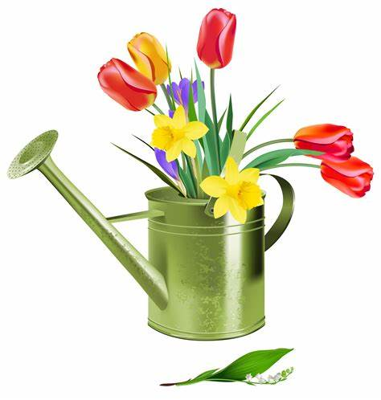
Remember our “big” competition at the April meeting .
You can enter as many items as you wish and in any garden-inspired category – art, craft, baking, an arrangement of flowers, display of fruit or veg or even a poem.
LOTS of PRIZES!

WK & NFWI NEWS
- Thank you to everyone who voted for the annual resolution . Our results were :
Dental Health Matters 14 votes
Impacts of poor housing conditions 8 votes
Say “No” to gambling advertising 8 votes
Improving outcomes for women in the criminal justice system
2 votes

We`ll be hearing how this compares with the national vote soon and exploring the most popular at our April meeting.

- Annual subscriptions for 2024-25 are £48, which is split between NFWI, WK Federation and our own WI. We receive £23.60.
IMPORTANT : PLEASE DO NOT PAY UNTIL APRIL as Brenda is in the process of closing our 23-24 accounts by 31st March for audit and payments made now for next year`s accounts cause complications!
- The Trustees Report 2023-24 will be on the stage at the March meeting. A vote will be held at WKF AGM later this month , where Jane will be our delegate. We look forward to her feedback next month.

- WK FED Stained Glass Mosaic Workshop 16th -18th May various venues lifestyle Day £36 + £15 kit Info on stage
- WK Fed Lifestyle Day 16th April Ditton £15 Info on stage
- WK Speakers` Auditions Ryarsh 19th April . £5 Info on stage
- WK Magical Afternoon Tea Hadlow 26th April £13.50

PLEASE NOTE All our ticket applications for WK Fed events are now made through our WI. Sign on the appropriate sheet and/ or see Jane who handles this for us.
Payment should also be made to made through us

Looking ahead ……

APRIL MEETING : Resolutions discussions and
“In the Garden” Competition

MAY MEETING : NB Owing to local Elections this will be on
FRIDAY MAY 3rd
Our Annual General Meeting plus “A Walk through the Archives” ,
an opportunity to review the past year and look back at photographs , albums and reports of Farningham WI in the past.

Join us from 7 for a glass of wine and assorted sharing platters.

JUNE MEETING : Happy Birthday to Us!
Birthday party with entertainment from `Miss Vintage`,

JUNE 15th FARNINGHAM CHURCH FETE – we`ll be organising the tea and cakes tent , which will hopefully be a fundraiser for us More information (and requests for cakes and help!) nearer the date.

SEPT 14th AUTUMN LUNCH at THE HILLTOP

PLEASE REMEMBER ! IF YOU ARE UNABLE TO COVER YOUR ROOM OR TEA DUTY, YOU SHOULD FIND A SWOP
Any help that you can give with clearing away (PARTICULARLY THE TABLES) at the end of meetings is very much appreciated!

