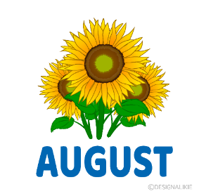
Farningham WI
FRIDAY AUGUST 2ND 2.00-4.00
SUMMER CRAFTERNOON

Try your hand at making beautiful – yet simple – paper flowers.
£3.50 pp includes tea, cake and materials
Please sign the board at this evening`s meeting

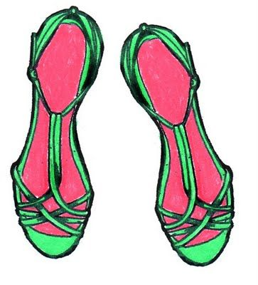
FRIDAY AUGUST 9th 2.00.- 4.30
Afternoon Tea with Helen Kendall-Tobias,
who will be telling us about “The Highs & Lows of Shoes”
Join us for a sandwiches, scones, jam, cream and cakes and enjoy Helen`s fascinating talk about the world of footwear .
£10 pp payable today
Final date for cancellations Aug 2nd

SAT AUG 3RD 2.00.P.M. THE SOUND OF MUSIC

Riverside Players Outdoor Production at Eynsford Castle
Marilyn has our tickets and will be standing near the path from High Street to Village Hall from about 1.40.
Phone 07743 711 555 if you can`t find her



SAT SEPT 14th 12.30 for 1.00 AUTUMN LUNCH
At The Hilltop Hotel

Welcome drink followed by 3 course meal
Check out the menu on the back page and sign up with your choices

This event is free for members of Farningham WI thanks to a very generous donation. However, I`m sure that you will understand that any lady cancelling after Sept 5th will be liable for the cost of her meal



FRI SEPT 20TH 2.00-4.00 BUNS & BOWLS : the return
(Just don`t let Irene anywhere near a wheelie bin)
Try your hand at short mat bowls- or watch those who do.
£2 pp inc tea and cake
Board at September meeting

FRIDAY OCT 11th 2-4 BRUSH UP YOUR FIRST AID & CPR
Ian Kelly will be updating us , including CPR and use of a defibrillator. £3 pp includes tea and cake
Sign Lynda`s board to inform numbers

URGENT ! SITUATION VACANT
Lady required to join Sally as a WI representative on Farningham Village Hall Committee.
Attend a few evening meetings a year and provide feedback to WI committee (email is fine)
Please see Marilyn or Sally S if you can help.

HAPPY BIRTHDAY

Anne (9th) Bridget (12th) Micaela (15th), Tina (18th), Jane G (18th)

News from our groups
FRIDAY WALKS Friday Aug 16th. Meet at Ightham Mote car park at 10.30 for a walk around the estate Join Tina`s `Whats App` group to receive updates.
PA & I LUNCH Wed Aug 14th 12.00 for 12.30 FVH ( Pam or Marianne)
SHORT MAT BOWLS Friday 16th Aug 1.30 Village hall (Irene)
BOOK GROUP Mon Aug 19th 7.00.p.m. “Force of Nature” by Jane Harper . Join the Whats App group to keep up to date
SCRABBLE Mon 2.00.p.m. TBC via Lynda`s `What`s App` Group

WK News
FEDERATION EVENTS

5th Nov HOW IS SCIENCE AFFECTING OUR EVERYDAY LIVES? 13:00 to 16:00 Sevenoaks Community Centre, Bat and Ball, £12.50
12th Oct 9.30-3.0 SPEAKER AUDITIONS
St Nicholas Church Hall Orpington £8
23rd Oct LIFESTYLE ANNUAL DAY
Ditton Community Centre £15

FULL DETAILS IN AUGUST WK NEWS - we`ll forward the link when available

PLEASE NOTE All our ticket applications for WK Fed events are now made through our WI. Sign on the appropriate sheet and/ or see Jane who handles this for us. Payment should also be made through us

HILLTOP LUNCH Sept 14th
MENU
Smoked salmon and prawn with wholemeal bread
Blue cheese, apple and walnut salad with balsamic dressing
Parma ham and melon
……………………………..
Beef Bourguignon and creamed potato, green beans
Sea-bream fillet, lemon and dill dressing, sauté potatoes
Vegetable tartlet, crushed new potatoes, tomato coulis
…………………………………
Creme brûlée, summer berries
Chocolate brownie with vanilla ice cream
Pancake, banana, whipped cream and maple syrup
Coffee/Tea

PLEASE REMEMBER ! IF YOU ARE UNABLE TO COVER YOUR ROOM OR TEA DUTY, YOU SHOULD FIND A SWOP
Any help that you can give with clearing away (PARTICULARLY THE TABLES) at the end of meetings is very much appreciated!
NFWI UPDATE
The 2025 ANNUAL MEETING will be held on JUNE 4th 2025.
This will be an online event attended by Federation reps, advisers etc and link delegates – although it is very unlikely to be our turn again as we attended this year. Observers are also able to apply for tickets.
We`ll have more information re our linked group and observer applications later in the year.
2025 Resolution
Each year NFWI invites members to submit resolutions which could form the basis of the national campaign. These go through a lengthy selection process, culminating in a member vote on a shortlist in January , then individual branch discussions on the chosen one(s) in April/May. You may remember the interesting evening we had in April focusing on Dental Health Matters.
Do you have a burning issue that you feel could lead to a national campaign? If so, this could be your moment!
Let Jane (or Marilyn) know and we`ll source the appropriate paperwork . Closing date AUGUST 15th .

NFWI UPDATE
The 2025 ANNUAL MEETING will be held on JUNE 4th 2025.
This will be an online event attended by Federation reps, advisers etc and link delegates – although it is very unlikely to be our turn again as we attended this year. Observers are also able to apply for tickets.
We`ll have more information re our linked group and observer applications later in the year.
2025 Resolution
Each year NFWI invites members to submit resolutions which could form the basis of the national campaign. These go through a lengthy selection process, culminating in a member vote on a shortlist in January , then individual branch discussions on the chosen one(s) in April/May. You may remember the interesting evening we had in April focusing on Dental Health Matters.
Do you have a burning issue that you feel could lead to a national campaign? If so, this could be your moment!
Let Jane (or Marilyn) know and we`ll source the appropriate paperwork . Closing date AUGUST 15th .

