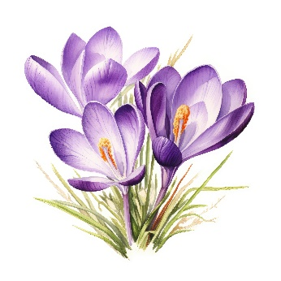
Farningham WI
February 2025

Winter warmer
FRIDAY FEBRUARY 21st 1.30 - 4.00
Chase way those Winter Blues with a
Fish & Chip lunch and Mini Picture Quiz
£10 pp includes free raffle ticket
Sign the board tonight
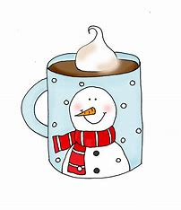
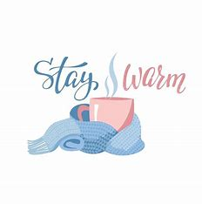

vote vote vote vote !

Remember to cast your vote tonight for our national 2025 resolution.

The shortlist is :
Let`s talk about incontinence
Bystanders can be lifesavers (CPR and defibrillators)
Join the repair revolution (clothing sustainability)
Eliminate landfill of medication packaging

Jane will send our decisions, to be be counted with votes from all UK WIs and the final choice will be discussed at our April meeting.
PAM FINCH
We were immensely saddened to hear the news that Pam passed away in hospital last month. She joined our WI in the 1980s and was a supportive and enthusiastic member. Not only did she serve on the committee for many years but was President twice, sharing the role with Pat the second time. She ran PA & I very successfully, latterly with Marianne, and chose interesting, quirky and occasionally moving, subjects for discussion. We shall miss her.
Her funeral will be held at Eltham Crematorium (North Chapel) on Monday February 10th at 11.00.a.m.

LET`s TALK about JOINing THE COMMITTEE……..
Help to support , build upon and continue the success of our WI!
We are seeking new members for our committee .
You have something to offer , whether it`s adding your views when making decisions, helping out in the background or playing a more active role. …….or any combination of all three! You can do as much as you feel comfortable with.
No particular talents required , just enthusiasm , tolerance and a smile.
Think about it ! We`ll be voting in the new committee at our AGM in May but you don`t have to wait until then to find out more.
Just have a chat with any committee member.
REMEMBER ! No committee , no WI!
Don`t leave it to everyone else……who knows, you might enjoy it. We do !
Committee meetings take place at FVH on the 1st Tuesday of each month 7- 9.30(ish)
Thank you to Linda F who has taken over the role of Kindness Correspondent from Irene.
She`ll be arranging cards and flowers (with Brenda) for ladies when needed.


HAPPY BIRTHDAY to our FEBRUARY Babies !
Val (9th), Julie (13th), Beryl (15th) and Lesley (17th)

WK & NFWI NEWS
- NFWI Annual Meeting, 4 June 2025
This is an online event this year . We are not due to send a representative but you may attend as an observer . Approx cost/donation £5. See Jane if interested.
- Safeguarding : West Kent Federation Safeguarding Officer (FSO) has created a PowerPoint presentation on Safeguarding plus a quiz. A link was sent out last week but if you wish to receive it again, please contact Jane or Marilyn.
- 5 Minutes That Matter: Have Your Say - The UK National Screening Committee has published a public consultation to determine thoughts on introducing HPV home testing kits freely on the NHS for eligible under screened people . NFWI will be submitting a response.
The WI’s `5 Minutes that Matter` campaign seeks to raise awareness of the importance of cervical screening and to help to address barriers to attendance . To inform the response to the consultation , they wish to hear about your experiences with HPV testing/cervical screening/smear tests . Information from your responses will be collated and sent to NHS England. Contributions will remain anonymous.
Information about ways to take part was distributed last week but if you would like it again please contact Jane or Marilyn.
- Catford WI Treasure Trail – 4 Bridges of London 31/5/25
Walking trail approx. 3-4hrs Start at Blackfriars station (10-10.30)
Teams (6 max) £6 pp . Closes 14/4. See Jane if interested.

- Applications for tickets for WK courses and events should be made through your WI. Please see Jane if there are any in WK News that interest you

News from our groups
PA & I LUNCH 12/2/25 12.00 for 12.30 FVH (Marianne)
CRAFT “Come `n Craft” 7/2/25 2.00-4.00 FVH (first Friday of each month going forward) Micaela
BOOK GROUP 17/2/25 7.00 FVH Join the Whats App group
SCRABBLE 14/2/25 2.00-4.00 FVH Join Lynda`s `Whats App` Group

PLEASE REMEMBER ! IF YOU ARE UNABLE TO COVER YOUR ROOM OR TEA DUTY, YOU SHOULD FIND A SWOP

