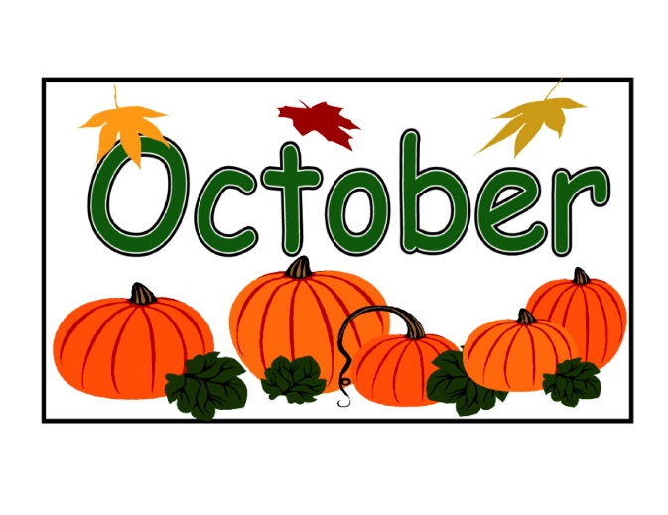
Farningham WI
It was lovely to see lots of ladies at our Autumn Lunch at The Hilltop. We`ve received so much good feedback that there can be no doubt that everyone enjoyed it. If you couldn`t make it, we missed you and raised a glass to you !
Thank you to Marj for the lovely photos. If you have already asked for copies, please collect from Laura. If you`d like to order a copy of one (or some) please give the details/ info to Laura and she`ll pass on the message.
There`s lots to look forward to in the next few months so be sure to the dates below………

Fri Oct 11th 2-4 Brush up your First Aid & CPR
Join us for an interesting – and valuable- presentation from Ian Kelly.
He`ll be updating us on first aid, including CPR and use of a defibrillator .
You could save a life! £3 pp includes tea and cake
See Lynda or sign the board this evening.


Sheila P (13th), Brenda B (14th), Zena (24th) Linda F (26th)
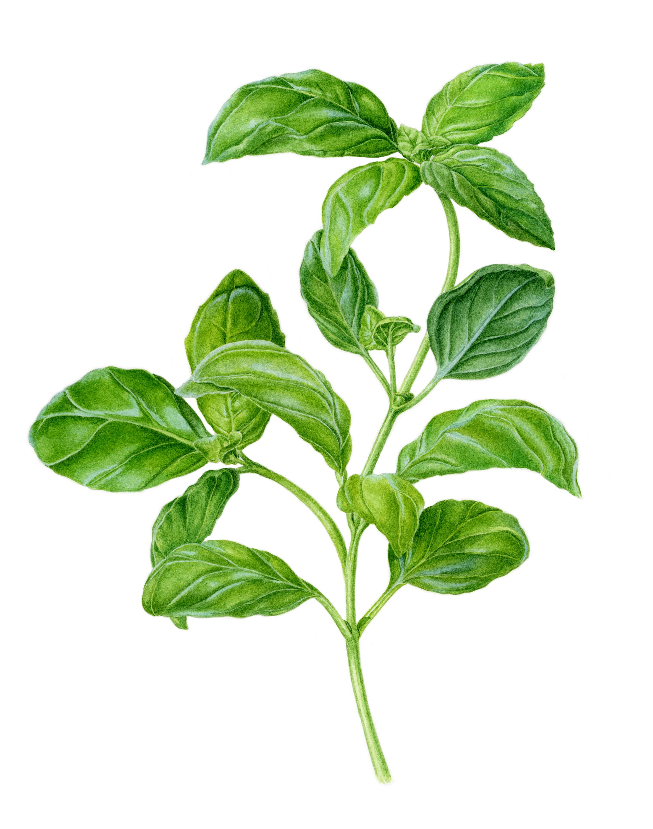Be Kind to your Winter skin
FRIDAY NOVEMBER 22nd 2-4
We welcome back Ana who will be showing how to make soothing and calming body balms and talking to us about the ingredients, properties and usage of different herbs. There`ll be an opportunity to make 2 balms to take home.
Cost £10pp includes the balms - they sell at £10 a jar so we`ll be getting a bargain! - and tea and cake.
Please sign the board and pay Micaela or via BACS
(This event is being subsidised from WI Craft funds)

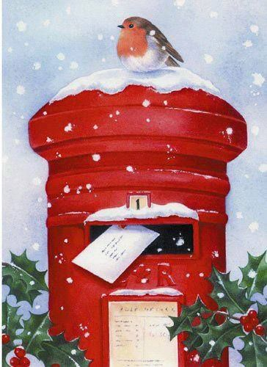 Post Early for Christmas!
Fancy sending a Christmas Card or two to some other WI members? Bring them along to our November meeting, pop them into Marj`s Postbox and she`ll sort and deliver them for you at the Christmas evening.
A few things to remember…
Please write first names and surnames on envelopes
Keep all your cards together with a rubber band or in a bag
PLEASE don`t think that you have to send any cards at all or should send a card to every lady. It`s just a convenient way to send one to any WI ladies you may wish to. ………..

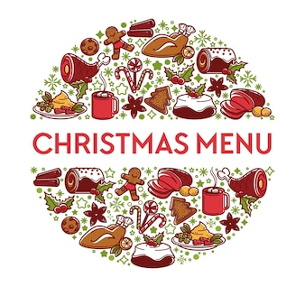
Christmas meeting

Not too long now until our Christmas Meeting on
Thursday December 5th !

Christmas Drinks and canapes from 7 o clock,
followed by a delicious meal from `Clare`s Catering`.
There`s a choice of main course, then a trio of puddings, with tea/coffee to finish.
Check out the main courses below and enter your choice on the list.

£16pp payable to Lesley in Oct or Nov or via bank transfer.

Closing date for signing up and food orders: NOVEMBER 13th
Final date for cancellations : NOVEMBER 20th

Thank you to our benefactor for her very generous donation, enabling us to keep payments affordable.

MAIN COURSE CHOICES

Baked sea bass with lemon caper dressing
served with new potatoes and tenderstem broccoli)
or
Roast turkey, sage and onion stuffing, pigs in blanket, roast potatoes,
buttered carrots with parsley, brussel sprouts, slow cooked red-cabbage
or
Aubergine stuffed with pisto
served with new potatoes and tenderstem broccoli

BUNS & BOWLS – and `Come `n Craft ` !

The hall was `buzzing` on Friday 20th for our first combined
Short Mat Bowls and Craft session.
Some ladies had a go at bowls, with expert tuition from June and Irene . (Brenda was a `natural`!)
Some ladies brought their own craft projects to work on.
Some ladies sat and encouraged the bowlers.
Everyone enjoyed tea, homemade cake and a chat.
Keep an eye out for the next session!
CHRISTMAS CRACKER - NOON
FRI DECEMBER 13th 2- 4
Join us for a fun-filled afternoon.
Mini- Christmas Tombola Festive refreshments
Have a go at making your own Christmas Cracker(s)
“Name the ………. “ and more seasonal surprises !
FURTHER INFO TO FOLLOW

News from our groups
FRIDAY WALKS Autumn walks to be confirmed. Join the Whats App group for updates
PA & I LUNCH Wed Oct 9th 12.00 for 12.30 FVH (Pam or Marianne)
SHORT MAT BOWLS Fridays Next one : Oct 4th 1.30 Village hall (Irene)
BOOK GROUP Mon Oct 28th 7.00.p.m. Join the Whats App group
SCRABBLE TBC Join Lynda`s `What`s App` Group

NFWI & West Kent
- DEVELOPING OUR STRATEGIC VISION 2025-2030
Consultation is now open to all members and runs until 1st March 2025. This is your opportunity to make your views known on the future direction of the WI as an organisation. A document outlining the background and draft vision statements is available. A copy is on the stage and Jane will send you a link if you ask. I`m sure that we`ll hear more in the coming months – and we`ll keep you informed- but it`s never too early to start…….
- Information on the latest West Kent activities can be found in the October edition of West Kent News. We`ll send out the link as soon as we receive it or it can be found on West Kent Fed website.

PLEASE NOTE All our ticket applications for WK Fed events are now made through our WI. Sign on the appropriate sheet and/ or see Jane who handles this for us. Payment should also be made through us

PLEASE REMEMBER ! IF YOU ARE UNABLE TO COVER YOUR ROOM OR TEA DUTY, YOU SHOULD FIND A SWOP
Any help that you can give with clearing away (PARTICULARLY THE TABLES) at the end of meetings is very much appreciated!

