
Farningham WI
November 2024
Be Kind to your Winter skin
FRIDAY NOVEMBER 22nd 2-4
We welcome back Ana who will be showing us how to make soothing and calming body balms and talking to us about the ingredients, properties and usage of different herbs. There`ll be an opportunity to make 2 balms to take home.
Cost £10pp includes the balms - they sell at £10 a jar so we`ll be getting a bargain! - and tea and cake.
Please sign the board and pay Micaela or Lesley direct or via BACS
(This event is being subsidised from WI Craft funds)




Angela (1st), Joan (4th), Sandra R (17th), Marj (19th), Linda M (22nd)

REMEMBER ! Have a go at Bernie`s Charles Dickens Quiz this evening! Prizes!
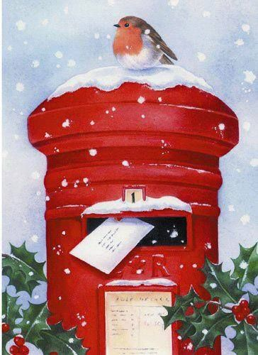 Post Early for Christmas!

Fancy sending a Christmas Card or two to some other WI members? Pop them into Marj`s Postbox at tonight`s meeting and she`ll sort and deliver them for you at the Christmas evening.
Not at the meeting? Just pop them through Marilyn`s door, before the end of this month and she`ll pass them on.

A few things to remember…
Please write first names and surnames on envelopes
Keep all your cards together with a rubber band or in a bag
PLEASE don`t think that you have to send any cards at all or should send a card to every lady. It`s just a convenient way to send one to any WI ladies you may wish to. ………..

Christmas meeting

Not too long now until our Christmas Meeting on
Thursday December 5th !

Christmas Drinks and canapes from 7 o clock,
followed by a delicious meal from `Clare`s Catering`.
There`s a choice of main course, then a trio of puddings, with tea/coffee to finish.
Check out the main courses on the next page and enter your choice on the list.

£16pp payable to Lesley in Nov or via bank transfer.

IMPORTANT : Closing date for signing up and food orders: NOVEMBER 13th
Final date for cancellations : NOVEMBER 20th

Thank you to our benefactor for her very generous donation, enabling us to keep payments affordable to all

CHRISTMAS MAIN COURSE CHOICES
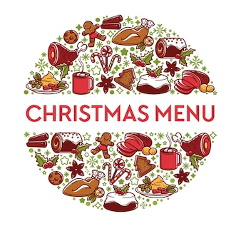
Baked sea bass with lemon caper dressing
served with new potatoes and tenderstem broccoli)
or
Roast turkey, sage and onion stuffing, pigs in blanket, roast potatoes,
buttered carrots with parsley, brussel sprouts, slow cooked red cabbage
or
Aubergine stuffed with pisto
served with new potatoes and tenderstem broccoli

CHRISTMAS CRACKER - NOON
FRI DECEMBER 13th 2- 4
Join us for a fun-filled afternoon!
Mulled wine on arrival
Christmas Mini- Tombola Festive refreshments
Have a go at making your own Christmas Cracker(s)
Cracker Lucky Dip “Who is most like Santa?”
and more seasonal surprises !
£6pp (payable on the day)
SIGN THE BOARD THIS EVENING OR AT OUR DECEMBER MEETING

News from our groups

An update on Caroline Gould
We have heard from Rob, Caroline`s son that she is mostly content and settled at Hale Place care home in East Peckham. Although in good health physically, sadly she continues to decline due to dementia and is finding communication increasingly difficult.
Some of her pictures (alongside those of her sister and niece) are on display in an exhibition at St Benedict`s Centre in West Malling on Sunday Nov 10th.
More info on the stage
Looking back at October ……..
- Thank you to everyone who brought in donations for Swanley Food Bank. They filled the back of Emma`s car and many were given away in a very busy session the next day. Following some requests , she has sent a link to make online donations
https://swanleydistrict.foodbank.org.uk/give-help/donate-money/
and her contact details
Emma Boyes Foodbank Manager Mobile: 07798 872 573

- And to Lynda for organising such a valuable CPR and Defib training session
- Laura was our lucky Bursary winner this year and recently attended a workshop, making some exquisite silver-wire jewellery. She`ll be at this evening`s meeting and is happy to show you her photos and tell you all about it.
Looking forward…….
- Our JANUARY MAIN MEETING has been rescheduled to
FRIDAY JANUARY 10th 1.30- 4.00
Join us for a fun Beetle Drive, tea and cake and some New Year treats.
(We haven`t forgotten our annual Fish and Chip lunch – look out for details of a Winter warmer event soon)
- Micaela will be organising regular informal Come `n Craft afternoons in the New Year . Bring your own on-going project or learn a new skill. Rumour has it that `Learn to Knit` is on the agenda……

Community News

- Thank you to Micaela and Lesley for producing our crocheted wreath which will be laid in Farningham on Remembrance Day . As usual we shall be making a donation to The Royal British Legion.
- We hope to sponsor a `Lights of Love` tree in St Peter and St Paul again this year. You can make a donation and sign our `communal card` in November and December. Marilyn will read out the card in December

NFWI & West Kent

- Interested in standing as a WK Federation Trustee? See Jane for information
- The shortlist of (4) resolutions for 2025 is listed in this month`s WI Life , Check them out before we vote in January .

News from our Groups

FRIDAY WALKS We`re aiming for a Christmas walk! Join the Whats App group for updates
PA & I LUNCH Wed Nov 13th 12.00 for 12.30 FVH (Pam or Marianne)
BOOK GROUP Mon Nov 27^{t} Christmas meeting and Lunch . Join the Whats App group for updates
SCRABBLE TBC Join Lynda`s `What`s App` Group
Scrabble will be `moving` to the Village hall from January to accommodate rising numbers (one Friday each month).

PLEASE REMEMBER ! IF YOU ARE UNABLE TO COVER YOUR ROOM OR TEA DUTY, YOU SHOULD FIND A SWOP
Any help that you can give with clearing away (PARTICULARLY THE TABLES) at the end of meetings is very much appreciated!

News from our Groups

FRIDAY WALKS We`re aiming for a Christmas walk! Join the Whats App group for updates
PA & I LUNCH Wed Nov 13th 12.00 for 12.30 FVH (Pam or Marianne)
BOOK GROUP Mon Nov 27th Christmas meeting and Lunch . Join the Whats App group for updates
SCRABBLE TBC Join Lynda`s `What`s App` Group
Scrabble will be `moving` to the Village hall from January to accommodate rising numbers (one Friday each month)

PLEASE REMEMBER ! IF YOU ARE UNABLE TO COVER YOUR ROOM OR TEA DUTY, YOU SHOULD FIND A SWOP
Any help that you can give with clearing away (PARTICULARLY THE TABLES) at the end of meetings is very much appreciated!

